Chapter 3 Question 11 - Michael Streyle

##   
## Call:  
## lm(formula = residual ~ dose)  
##   
## Residuals:  
## Min 1Q Median 3Q Max   
## -3.4333 -1.7000 -0.2667 2.1000 4.7667   
##   
## Coefficients:  
## Estimate Std. Error t value Pr(>|t|)  
## (Intercept) 0.0000 0.9598 0.000 1.000  
## dose -0.5667 1.1755 -0.482 0.644  
##   
## Residual standard error: 2.879 on 7 degrees of freedom  
## Multiple R-squared: 0.03213, Adjusted R-squared: -0.1061   
## F-statistic: 0.2324 on 1 and 7 DF, p-value: 0.6445

## Loading required package: zoo

##   
## Attaching package: 'zoo'

## The following objects are masked from 'package:base':  
##   
## as.Date, as.Date.numeric

##   
## studentized Breusch-Pagan test  
##   
## data: hfit  
## BP = 6.0215, df = 1, p-value = 0.01413

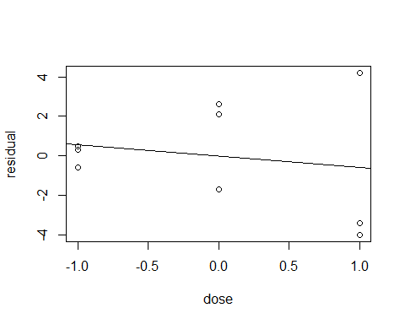

Chapter 3 Question 11

Written Out Answers

1. See the above plot of *ei* against X*i* . As the dose values go from -1 to 1, the absolute value of the residuals get larger, suggesting non-constant variance.
2. Constancy of error variance corresponds to y1 = 0. The alternatives are *H0*: *y1* = 0 and *Ha*: *y1* ≠ 0. The decision rule from page 119 is as follows: If X2BP ≤ x2(1 – α, *df*), then conclude *H0,* and if X2BP > x2(1 – α, *df*), then conclude *Ha.* In this case, x2(1 – α, *df*) = 3.84. The BP value from the BP test function, is 6.0215. Since 6. 0215 > 3.84, we conclude *Ha,* that the error variance is not constant. The P-value of the test is 0.01413, which is small and supports the lack of constant variance. This test supports my findings in part (a) which suggests non-constant variance.